Chapter 19, Solution 2.

Consider the circuit in Fig. (a) to get 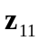 and 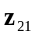.
I₂ = 0
1 
1 
1 
+
V₁
−
1 
I₁
(a)
I_{o}
+
V₂
−
1 
1 
I_{o}'
1 
1 
1 
1 
1 

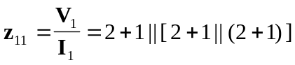
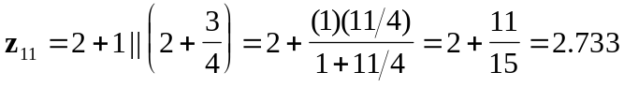

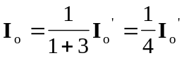
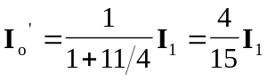
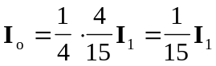

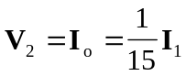

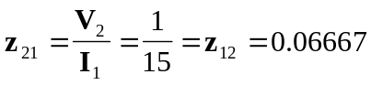

To get 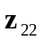, consider the circuit in Fig. (b).
1 
1 
1 
1 
(b)
1 
1 
1 
1 
1 
1 
1 
+
V₁
−
+
V₂
−
I₂
I₁ = 0

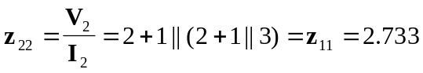

Thus,
